Software Engineering CSC 4350 - Spring 2017 - MW 5:30pm to 7:15pm

Team: *Five Guys*

Members consisting of:

Brandell Petty (Team Coordinator)

Harold Fletcher

Matthew Chuong

Hanan Kwok

Paul Vlahos

Project Name: *Blue Moon Suites*

*4/21/17*

Table of Contents

1. Description of the Project – pg. 3
2. System Analysis & Design with use cases, Sequence Diagrams & Category Interaction Diagram – pg. 4
3. Test Cases Used – pg. 5
4. Shall Statements– pg. 6
5. Object Design pg. 7
6. Rationale for Entire Project & Implementation pg. 8
7. Dictionary – pg. 9
8. Updated WSD – pg. 10
9. Resumes – pg. 11
10. Function Point Cost Analysis & COCOMO Results Comparison & Conclusion– pg. 20
11. Project Legacy – pg. 22

*Description of Project: Blue Moon Suites*

Our project is based on the suggested topic, hotel management system. In our project, we provide several features that a standard hotel management system should normally have. The project is based on a web application that runs on an engine called Meteor. The web application was built with the intention of external uses combined with internal uses making it versatile. Our idea of Blue Moon Suites is to make the customer experience seem-less, with the allowance for customers to check in and check out from our website. With this feature, along with the many other features our web application must offer, it creates a pleasant customer experience. The web application offers information regarding hotel events, amenities, as well as the several locations of said hotels and resorts. The website allows users to log in and out of an account they’ve created with the convenience of editing their reservations, meaning allowing them to make or cancel one, as well as allowing them to check in or out. For the check in, check out feature, the user must possess an account. It also allows administrative privileges based on the account information used when logging into the website. The administrative page (when completed), will allow a manager to view trends in customer traffic as well as profits made or loss. On our contact page, anyone with inquires can contact a set email that is encoded into the website for all different types of questions. This hotel management system is truly one of a kind in its design and uses, and could be implemented within any hotel management system.

System Analysis & Design with use cases, Sequence Diagrams & Category Interaction Diagram.

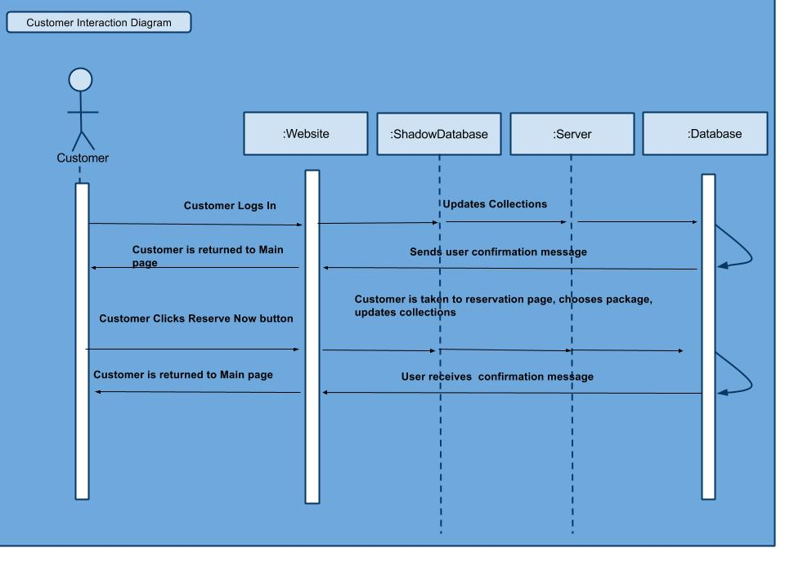

|  |  |
| --- | --- |
| USE CASE | CUSTOMER LOG IN |
| ENTRY CONDITIONS | CUSTOMER IS ON THE SITE |
| FLOW OF EVENTS | 1. CUSTOMER CLICKS LOG IN TAB 2. CUSTOMER ENTERS EMAIL AND PASSWORD 3. CUSTOMER CLICKS ENTER |
| ALTERNATE FLOW OF EVENTS | NONE |
| EXIT CONDITIONS | IF SUCCESSFUL THE CUSTOMER IS LOGGED IN OR PROCEEDED AS A GUEST |

|  |  |
| --- | --- |
| USE CASE | ADMIN LOG IN |
| ENTRY CONDITIONS | ADMIN IS ON THE SITE |
| FLOW OF EVENTS | 1. ADMIN ENTERS IN USERNAME AND PASSWORD 2. ADMIN IS TAKEN ADMIN PAGE |
| ALTERNATE FLOW OF EVENTS | NONE |
| EXIT CONDITIONS | IF SUCCESSFUL THE ADMIN IS LOGGED IN OR PROCEEDED AS A GUEST |
| USE CASE | CUSTOMER CREATES ACCOUNT |
| ENTRY CONDITIONS | CUSTOMER IS ON SITE |
| FLOW OF EVENTS | 1. CLICKS CREATE ACCOUNT TAB 2. CUSTOMER ENTERS IN INFORMATION FIELDS 3. CUSTOMER CLICKS REGISTER 4. CUSTOMER IS RETURNED TO MAIN PAGE |
| ALTERNATE FLOW OF EVENTS | NONE |
| EXIT CONDITIONS | IF SUCCESSFUL THE CUSTOMER NOW HAS AN ACCOUNT |

|  |  |
| --- | --- |
| USE CASE | CUSTOMERS MAKE OR CANCEL RESERVATIONS |
| ENTRY CONDITIONS | CUSTOMER IS LOGGED IN |
| FLOW OF EVENTS | 1. CUSTOMER CLICKS RESERVE OPTION 2. CUSTOMER VIEWS AVAILABLE ROOMS 3. CUSTOMER SELECTS THE ROOM 4. CONFIRMATION MESSAGE WILL BE DISPLAYED |
| ALTERNATE FLOW OF EVENTS | 1. CUSTOMER CLICKS RESERVE OPTION 2. CUSTOMER VIEWS RESERVATIONS MADE 3. CUSTOMER SELECTS CANCEL RESERVATION 4. CONFIRMATION MESSAGE WILL BE DISPLAYED |
| EXIT CONDITIONS | IF SUCCESSFUL THE CUSTOMER HAS MADE OR CANCELED RESERVATIONS |

Test Cases Used

The test cases used were all functional cases of the program.

*Test 1:* Customers can log into an account or proceed as guests.

*Test 2:* Customers can view prices for hotel rooms.

*Test 3:* Customers can make and cancel a reservation.

*Test 4:* Admins can log into admin-only accounts.

*Test* 5: Customers can check in & out of the hotel.

Shall Statements

HMS-1.0 Introduction

A hotel is to contain 100 guest rooms and a software system, named Blue Moon Suites. The software will act as an interface to both customer needs and to staff managing the hotel.

HMS-2.0 Blue Moon Suites

Blue Moon Suites shall keep track of the status of all hotel rooms and all guests. There shall be 100 rooms within the hotel.

HMS-2.1 Blue Moon Suites Data

Blue Moon Suites shall record the following data on check-in:

* How many guests checking into a room.
* What room the guest is staying in.

HMS-3.0 Check-In/Check-Out

The customer shall be able to log into the website as a guest or using a created account. A logged in user shall be able to reserve a room for a date and an amount of time. A customer shall be able to cancel a reservation. The staff shall be able to log into the system from a staff account. The manager shall be able to log into the system with an admin account.

HMS-3.1 Check-In Details

The system shall cancel a customer’s reservation if the customer does not check-in within 12 hours of their reservation. The system shall inform the user that no room is available currently with their input specifications.

HMS-3.2 Check-Out Details

The customer shall be able to check-out before the designated reserved date of check-out.

HMS-4.0 Data

The system shall record the time an employee clocks in. The system shall record the time an employee clocks out.

Object Design

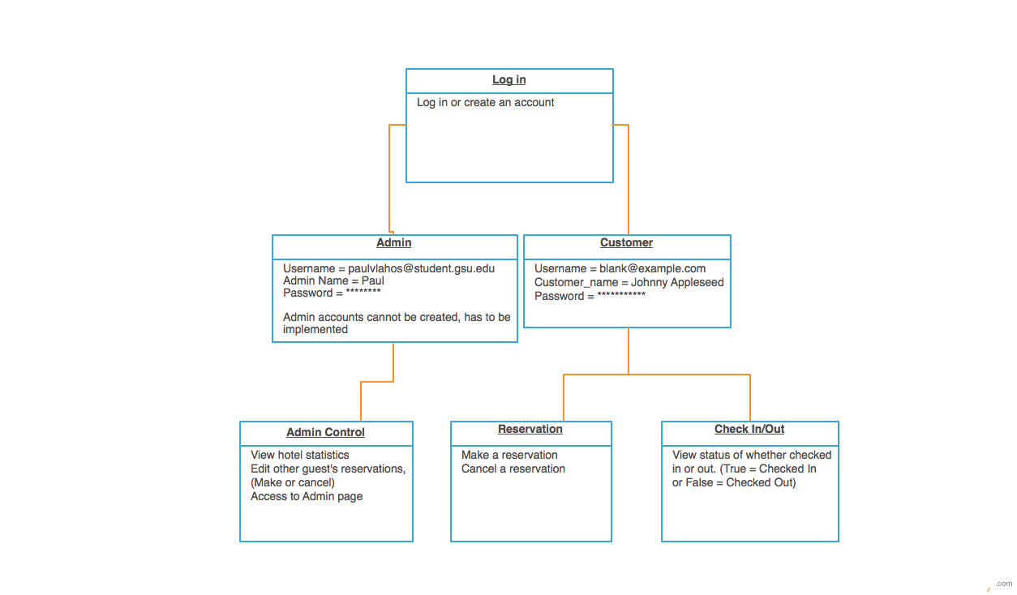

Rationale for Entire Project and Implementation

Blue Moon Suites offers premium four-star hotel service. The hotel will have a total of 100 rooms due to how massive each room will be. The hotel will have three kinds of rooms on 5 separate floors, Standard, Deluxe, and VIP which will be located on the top floor. Customers wanting to check into the hotel will be able to do so online as well as check out. The hotel should have the functionality of checking in and out to be automatic, to avoid the needs of a receptionist unless needed for specific tasks. Users will also be able to make a reservation or cancel if needed.

The Hotel Management System that will be a web application is linked to a database which is controlled by our tool that is called Meteor.

Different login credentials will be given to users based on their business with the hotel. If a user who’s a customer would like to create an account to access different functionalities such as checking in and checking out, then the user should be able to do so. Otherwise an Admin account which exclusively must be set by the hotel, will be made, and can be accessed by the website to explore administrative functions a hotel will need.

Users that create an account on our website will have their information pushed to a database which will store the information so that the user can access his or her account at any time. The database will update in real time allowing the web application to run consistently without the need of refreshing.

The system will also notify the staff which room needs to be cleaned, since a guest has just vacated it. Until housekeeping logs the room into the database as cleaned, no guests will be checked into that room. It is essential that a management system has different access areas for different users, either costumer, staff, or management. Different user permissions are set by using passkeys, so that regular customers can’t access information meant to be private to management. Employees will have a limited view in comparison to that of management.

1. The user must make an account to check in and out.

2. The user must make sure they enter the correct username and password, for them to access account functionality.

3. The user must use a valid email to register an account.

4. The admin user must already be implemented into the system to have access to the account.

5. Users will be able to browse the many amenities the hotel must offer.

6. If needed the hotel can contact Blue Moon Suites directly by leaving their contact information.

Dictionary

* Application - a program or piece of software designed and written to fulfill a requirement given.
* Blue Moon Suites (BMS) - The name of the hotel’s establishment. Blue Moon Suites provides accommodations for guest such as meals, traveling, indoor pool area, and many more.
* Clock in/Clock out - the act of a hotel employee clocking in and being recorded for time worked, then clocking out, ending the recording of time.
* Database - a structured set of data held in a computer, especially one that is accessible in various ways.
* Employee - a person employed under Blue Moon Suites.
* Guest – a visitor staying at Blue Moon Suites.
* Graphical User Interface (GUI) - is a human-computer interface (i.e., a way for humans to interact with computers) that uses windows, icons, and menus and which can be manipulated by a mouse (and often to a limited extent by a keyboard as well).
* Hotel Management System - An electronic system used by both guests and executive position holders of the establishment to manage the business of a hotel.
* Java - a general-purpose computer programming language designed to produce programs that will run on any computer system.
* MongoDB - is an open source relational database management system. Information in a database is stored in the form of related tables. Databases are typically used for web application development (often accessed using PHP).
* Suite - room that shares a wall with an adjoining room and is connected by a private door. Type of: bedchamber, bedroom, chamber, sleeping accommodation, sleeping room. a room used primarily for sleeping.
* Web Application- a client–server software application in which the client (or user interface) runs in a web browser. Common web applications include webmail, online retail sales, online auctions, wikis, instant messaging services and many other functions.

|  |  |
| --- | --- |
| Brandell Petty | Team Coordinator  Technical Writer  Manager  Database Management/Development  HTML/CSS Developer  Presentation |
| Harold Fletcher | Human Factor Specialist  Use Case Developer  Presentation |
| Matthew Chuong | Developer  GUI Tester  Human Factor Specialist  Interaction Diagram Creator |
| Hanan Kwok | GUI Tester  HTML/CSS Developer  Function Point Cost Analyzer  COCOMO Specialist |
| Paul Vlahos | HTML/CSS/JavaScript Developer  Database Development  RTM Creator  Presentation  Tool Specialist (Meteor) |

Matthew Chuong

195 Hidden Lake Drive, Fayetteville GA 30215 | (C) 6783327801 | [mstchuong@yahoo.com](mailto:mstchuong@yahoo.com)

Professional summary

Knowledgeable Computer Science expert skilled in data collection, analysis, and management. Works well under pressure and consistently meets deadlines and targets while delivering high quality work.

Skills

* Experienced in HTML
* Experienced in Java
* Experienced in UNIX
* Experienced in SPARC
* Experienced in Blender
* Some knowledge in Agile
* Knowledge in SQLite/MONGO
* Experienced in PHP
* Experienced in C
* Some knowledge in Meteor
* Some Knowledge in Bootstrap
* Experienced in GitHub

Work history

Software management and technician Jun 2014-Current

Joe Usher Peachtree City, Georgia

* Modified existing software to correct errors, adapt to new hardware and improve performance.
* Performed regression and system-level testing to verify software quality and function before it was released
* Oversaw major new enhancements to existing software systems.
* Debugged and modified software components

Education

Bachelor of Science: Computer Science 2011-2018

Georgia State University Atlanta

* Coursework in Web Design and Development
* Coursework in Graphic Arts and Animation
* Coursework in Assembly Language

High school Degree 2007-2011

Whitewater High School Fayetteville

Personal Profile

My personal interest includes fighting games, 3d modeling, and martial arts. I am currently a technician at United Radio.

* Age: 24
* Engaged
* Good health

Name: Hanan Kwok

Current position: 3rd year college student, computer science major

Past education: North Gwinnett High School (various courses over 4 years, including some courses that count for college credit)

Current education: majoring in computer science at Georgia State University

Skills (most computer science skills gained from college classes):

Basic knowledge of the programming language Java (including data structures such as stack, array, array list, linked list, queue, and binary trees)

Basic knowledge of UNIX and of the programming language C

Small amount of experience with SPARC assembly language

Basic knowledge of using computers

Has experience in 3 spoken languages (English, Spanish, and Mandarin & Cantonese dialects of the Chinese language, first language is English, basic experience in the other languages)

Basic experience in music from participating in orchestra throughout middle and high school (playing the viola)

Past project(s): small programs assigned in various classes as homework or classwork covering topics such as properties of Object-Oriented Programming (mainly in the language Java), data structures and their implementation, basic use of SPARC assembly language, the basics of UNIX, and the basics of the programming language C; and a small group project in a software engineering class to learn the general process involved in a software development project

Current independent project(s): a login page for a library system used by the library staff

**Harold Fletcher** hfletcheriii1@student.gsu.edu

(678) 876-7426[Address, City, ST ZIP Code]

Current senior at Georgia State University seeking internship and employment opportunities in the fields of software development, information technology, data and systems analysis, web development, and project management.

**Education and Certification**

**Georgia State University, Atlanta, GA** August 2013 - Present

Major: Computer Science Expected graduation date: May 2017

**Atlanta Institute of Music and Media, Atlanta, GA**

Certificate of Musicianship Completion date: May 2009

Focus: Guitar Performance and Instruction

**Related Coursework**

Principles of Computer Science Theoretical Foundations of Computer Science

Principles of Computer Programming Data Structures

Single Variable Calculus II Mathematical Modeling for Computer Science

**Professional and Work Experience**

**Recycling Management Resources** September 2013- June 2014

Shipping and Receiving

* Extensive experience with heavy machinery, of which included operating a bailer, driving forklifts, and other tasks involved in the process of recycling paper and plastic materials.
* Generated habits of hard work through intensive labor and gained familiarity with the operations of output and manufacturing based industry.

**Mellow Mushroom** January 2011- September 2013

Kitchen Manager

* General management responsibilities over daily kitchen operations, among which includes shift scheduling, expedition of food and beverages, and assurance of food quality.
* Promoted personal development of critical thinking skills, rapid response to crisis, and the ability to work with others while under pressure.

**Independent Music Teacher**  June 2010 – December 2010

Guitar Instructor

* Taught private guitar lessons and helped students to reach personal goals while instructing them in both the technical and creative aspects of the instrument. Assumed responsibility over their musical success.

**Team One Construction** August 2009 - June 2010

Floor Worker

* Constant exposure to various tasks and services in the construction field.
* Experience disassembling ATM machines and other electronics.

**Skills**

* Developing computer programming skills in Java along with knowledge in other quantitative fields
* Able to perform effectively under pressure and works easily with peers
* Responds rapidly in a crisis and to utilize critical thinking skills
* Possesses extensive knowledge of digital audio workstations including Ableton Live, Reason and Sonar, along with mastery of analog synthesis techniques

**Activities and Leadership**

* Creates original music through the use of multiple digital audio workstations and other digital mediums released worldwide through NON records.
* Performed original compositions in Amsterdam, NL.

**PAUL VLAHOS**

2615 Mercedes Drive pvlahos1@student.gsu.edu

Atlanta, Ga 30345 (404)-510-6178

**EDUCATION & DEVELOPMENT**

|  |
| --- |
|  |

Georgia State University, Atlanta, GA

*Computer Science Major (concentration in software engineering)* August 2013- Present

* **Cumulative GPA**: 3.12/4.00
* **Accomplishments/Awards**: Accepted to Honors College at GSU. Eagle Scout. Built three computers from miscellaneous parts in order to better understand the functionality and makeup of computers and for fun.

**SPECIALIZED SKILLS AND CERTIFICATIONS**

|  |
| --- |
| * **Language:** Literate in Greek * **Computers:** Proficient in Microsoft PowerPoint, Word, Excel, Adobe Photoshop, Java, C, C#, C++, and Lua. * **Certified** in American Red Cross CPR and First Aid certification. |

**LEADERSHIP EXPERIENCE**

|  |  |
| --- | --- |
| **Camp Kudzu,** *Camp Counselor,* Summer 2016.  Assisted in two consecutive week-long camp sessions that aimed at instilling beneficial management habits for diabetic children.   * Mentored 9 children (a. 13-15) while managing their daily schedule and ensuring they arrived at each activity on time. * Educated my mentor group on how to monitor their blood sugar, carb count, and correcting their blood sugar with insulin using the Correction Factor.     **Elementary School 1,** *Math and Technology Tutor*, Kefalos, Greece, Summer 2013-Summer 2016  Each summer, I spend 3 weeks with my family in Kos, Greece. I volunteer at a summer camp for primary school kids (a. 6-12), to enhance their knowledge on basic math and technological skills.   * Demonstrate how to use computers effectively by teaching the children how to navigate the internet to enhance their knowledge base for other disciplines. * Instruct children how to type, use word, and power point. * Provide extra lessons on fundamental mathematical concepts (i.e. fractions, probability, geometry, and multiplication and division tables)   **WORK EXPERIENCE**   |  | | --- | |  |   **Papa Johns,** *Delivery Driver,* Atlanta, GA, Summer 2016-Present. *22-23hrs/week*   * Communicate with customers in order to provide efficient and beneficial service as well as enhance customer relations skills. * Oversee and maintain computer systems to prevent any disruptions and fix any glitches/problems that arise during the week, in order to ensure customer satisfaction and a productive working environment. |

**Brandell Petty**

9230 Gallitin Drive SW, Covington, GA 30014

(646) 271-5351

brandell_j_petty@hotmail.com

**Education**

Georgia State University. Atlanta, Georgia. January 2015 to Present

Bachelors of Science (Expected Fall 2017)

* Current GPA: 3.11

Classes Taken:

* Data Structures CSC 3410, Grade received: B-.
* Math Models for Computer Science CSC 3030, Grade received: B.
* Computer Org & Programming CSC 3210, Grade received: B+.
* System Level Programming CSC 3320, Grade received: B+.
* Computer Architecture CSC 4210, Grade received: B+.
* Design & Analysis: Algorithms CSC 4520, Grade received: A-.
* Windowing Systems Programming CSC 4380, Grade received: A-.

Atlanta Metropolitan State College. Atlanta, Georgia. December 2012 to December 2014

Associate of Science - Computer Science

* National Honor Society Nominee (2013)
* GPA: 3.01

**Skills**

* Computer Programming – Encrypting programs using programming languages such as JavaScript, C, and C#.
  + Personal projects: [Heapsort Algorithm](https://github.com/Frosty5000/Heapsort-Algorithm) , [Drawing Art Application](https://github.com/Frosty5000/SimpleDrawingApp), [Stopwatch Application](https://github.com/Frosty5000/StopWatch), [Hotel Management System](https://github.com/Frosty5000/BlueMoonSuites/) (Group Project).
* Computer Intelligence – Up-to-date knowledge of the latest commonly used operating systems such as iOS, Mac OS, and Windows 7 – 10.
* Interpersonal Communication – Able to adapt to any personality or mood in various situations.
* Team/Leadership Skills – Very good working in groups or with employees as well as taking everyone’s actions into account.
* iOS Technical Skills – Analyzing, probing, and providing correct technical solutions to issues involving iOS based products as well as iCloud issues.

**Experience**

Apple Store. Buford, Georgia. November 2016 to Present

*Technical Specialist*

* Troubleshooting issues on iOS devices and macOS Sierra, both software and hardware related.
* Provided exceptional customer service.
* Aided in repairs when necessary.
* Assisting teammates with areas around the store.

Apple College AHA Program – Georgia State University September 2015 to November 2016

*iOS Tier 1 Advisor*

* Troubleshot issues based upon iOS devices such as iPad, iPod, and iPhone as well as iCloud issues.
* Provided exceptional customer service.
* Assisted teammates when requested or needed.
* Provided correct solutions based upon the customer’s problem using screen sharing tools as well as guided instruction.
* Able to adjust with any communication style.

Achievements

* Recognized for Exceptional Customer Experience in March 2016 – The customer left an extremely flattering VSAT survey comment.
* Placed 2nd in the “Effective and Efficient Olympics” for the second fastest AHT (Average handle time) of 15.74 and an above average IR (Issue resolution) of 85.71%.

AAA Parking. Atlanta, Georgia. May 2015 to September 2015

*Valet/Driveway Supervisor*

* Responsible for driving customers’ cars to and from the front drive.
* Greeting guests with hospitality and professionalism.
* Maintaining a clear or flowing driveway to avoid traffic.
* Assisting guests and their needs related to their cars.

Achievements

* Awarded a Certificate of Appreciation for Most Parked Vehicles Per Hour on July 11, 2015.

Kumon, Peachtree Battle. Atlanta, Georgia. February 2014 to September 2015

*Kumon Assistant*

* Troubleshooting problems with anything technology related.
* Input the grades of students on a program called CMS Standard.
* Graded the kid’s class work and homework.
* Alphabetically placing the kid’s folders that were filled with work.
* Directly helping children with their class work.
* Maintained a clean and sanitized center.
* Inputting the number of worksheets needed for worksheet inventory as well as special tests.
* Directly contacted parents concerning their child’s progression

Kumon, Fayetteville, Georgia August 2013 to February 2014

*Kumon Assistant*

* Input the grades of students on a program called CMS Standard.
* Directly helping children with their class work.
* Graded the kid’s class work and homework.
* Alphabetically placing the kid’s folders that were filled with work.

Function Point Cost Analysis & COCOMO Results Comparison & Conclusion

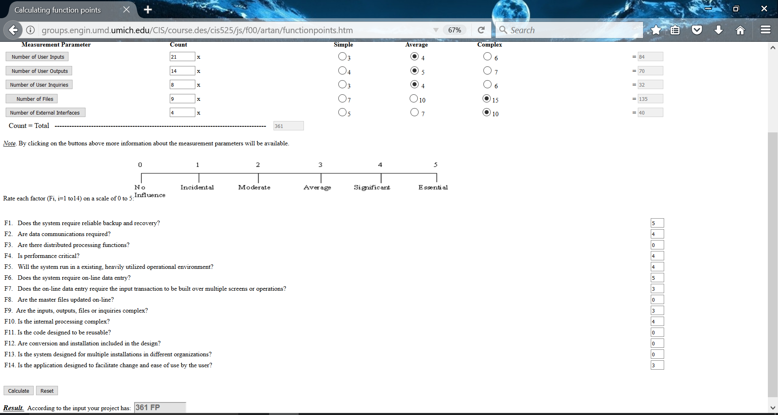

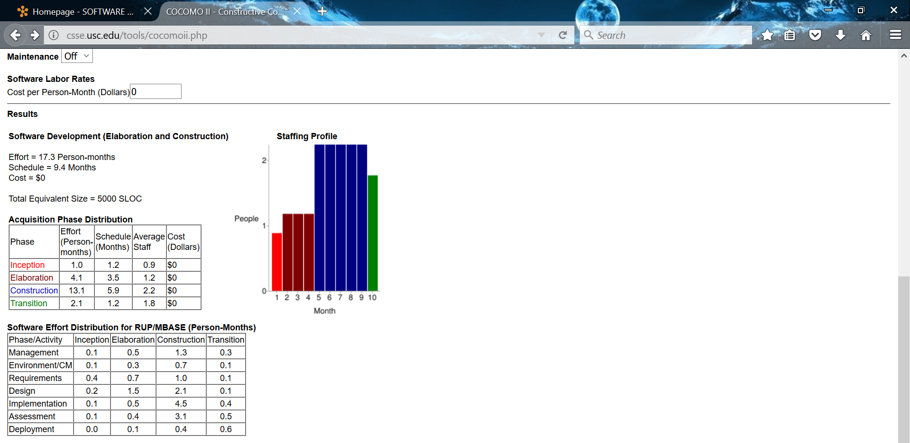

For BMS’s Function Point Cost Analysis our result was 361FP

For BMS’s COCOMO our result was 17.3 Person Months & 9.4 Months.

With these results the conclusion for this project would show that the ideas and requirements that were made for BMS would exceed the time given to finish the project in its entirety. However, as a group, we were still able to get a considerable amount of work done.

Project Legacy

When looking over the completion of Blue Moon Suites, one could say that the project can never be truly complete. With so many more ideas that Five Guys would have loved to implement, time was the main adversary. Looking over the project as a group, we’re able to say that we came a long way considering we started with absolutely no idea where to start. The final product that we achieved, although not fully complete to what we envisioned, is still something that we can say we’re proud of. Some of us within the team had very minimal to no experience dealing with some of the tools we used to make the web application. This became a challenge to us since we all had to learn something completely new while fumbling around with how to make components work to eventually have a working product. We also wanted to mention why we steered so far off from what was expected.

We understood that some of the requirements were to use Java8 which our team specifically avoided due to us having all our functionality stemming from JavaScript. We figured that JavaScript would be sufficient since we were making a web application, and using Java would’ve had minimum usage when it seemed efficient at the time to just have all the functionality coded using JavaScript. Also as a team we wanted to take a dive into unknown territory by strictly sticking to JavaScript because we wanted to make a learning experience out of this project. Our entire college career at GSU has been to use Java, and since we had freedom in this project we wanted to break away from that chain. We felt that we would not have learned nearly as much by continuing to code in the same language we were first introduced to at this school. We understood the reason being it’s for consistency and ease in a professor being able to run a program and properly grade the assignment, but with a proper description of how to run and use the program provided with a demonstration, we felt these would be equivalent tools for the professor to grade the assignment as it would be with Java included.

To close out our legacy for Blue Moon Suites, we want to discuss the many challenges we faced in making this web application. As mentioned along with gaining the skills acquired to make a web application, we also faced the challenge of making the bigger picture. The project really took off once we discovered the use of Meteor which is a tool that has been previously explained. Discovering this tool helped us mold the project together because we had everything we needed for creating a web application within arm’s length. Although we needed software to run the application initially, the best thing about the tool we started using is if needed, the website could be made live. Meaning you would only need an internet connection to explore the web application. Since the entirety of the project is on GitHub, it made projecting the website to the web redundant. With us being able to strive through by just learning a few basic tools, we inevitably came out with the final product of Blue Moon Suites. We concluded that if anything could have been done differently and still within a timely manner, it would be to in fact make a java application that would link to this web application. This would’ve allowed for us to have a more concrete internal system, while still being customer friendly to the user, and as a bonus to GSU, there would have been some Java.